Files that can be uploaded:
Disclosures Annual returns Announcement Core SGF CSR Other discloser
Existing : Only Pdf
New: docx, pdf, xls
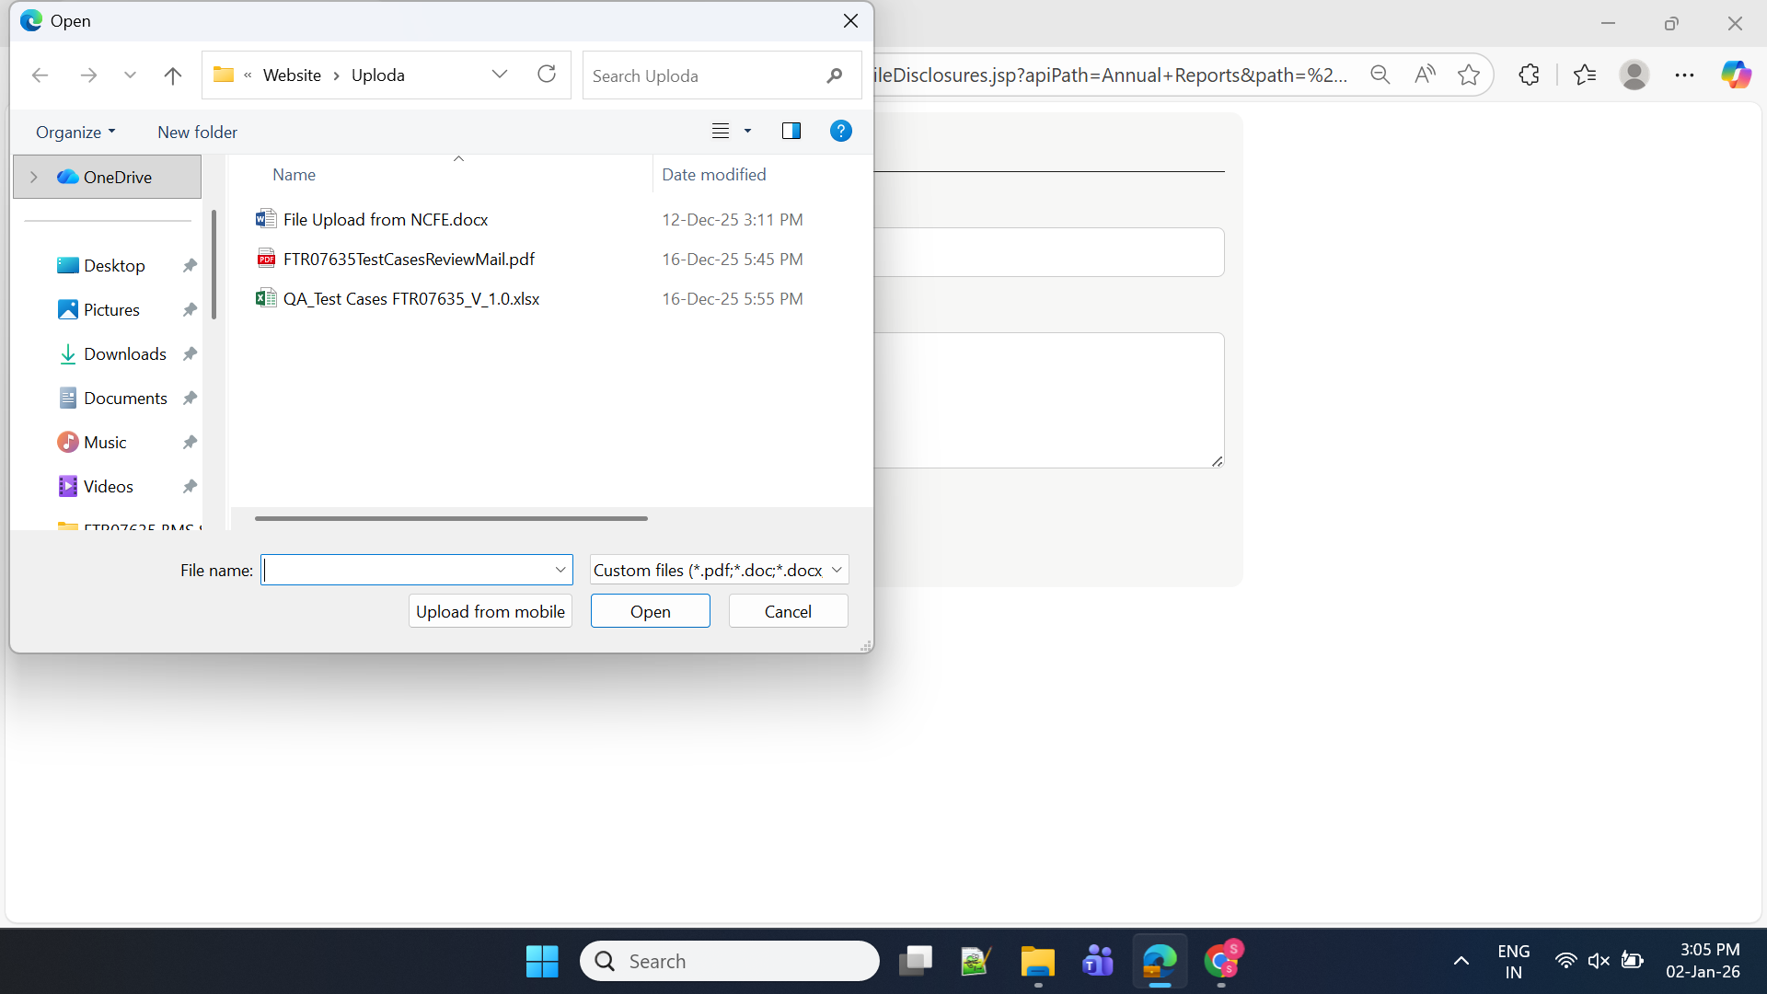

Files can’t upload:
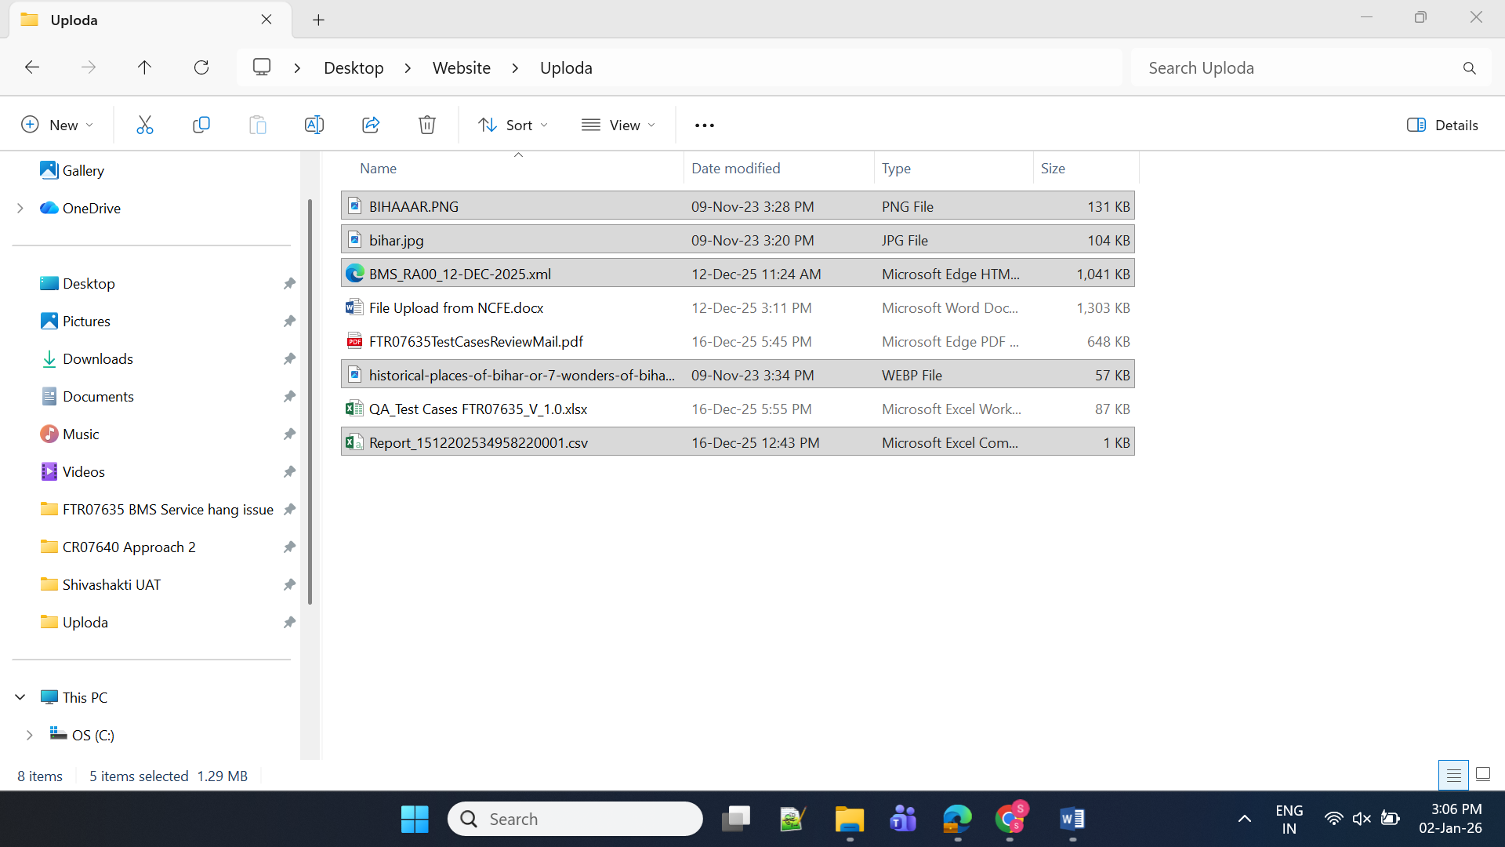

Not able to upload Doc in Shareholding pattern

Legal farework view is different in new

Exist : Whistle blower policy in new tab
New : same tab

Pfmi not visible in exist

